Analysing ELECTROLYTIC cells - Answers
For each cell described below:
  - Describe the observations and relate your observations to the species involved
  - Describe what is being oxidised and what is being reduced in each cell. Justify the oxidation and reduction half reactions in terms of e transfer and/or oxidation number
  - Write half equations and then a balanced net ionic equation
  - Calculate cell potentials using your data sheet, state whether the reaction is spontaneous or not and relate this to energy input/output

Cell 1
Cell 1
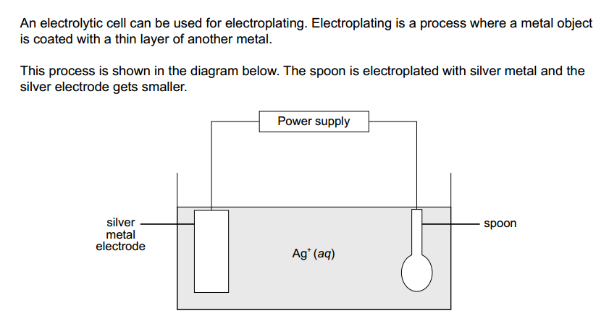

E°cell = E°(R) - E°(O), = 0.80 – 0.80 = 0.00V
Reduction: Ag⁺ + e → Ag (reduction as ON of Ag is decreasing from +1 in Ag⁺ to 0 in Ag, decrease in ON = reduction)
Oxidation: Ag → Ag⁺ + e (oxidation as ON of Ag is increasing from to 0 in Ag to +1 in Ag⁺, increase in ON = oxidation)
Observations: No colour change in the solution as Ag+ is colourless and is being produced by oxidation and removed by reduction. The anode (silver electrode) would decrease in mass as Ag is oxidised and the spoon would be coated in a grey/silver solid of Ag and would increase in mass as Ag+ is reduced to Ag at the cathode.
The E°cell is zero, therefore the reaction is non-spontaneous. For this reaction to occur, an input of electrical energy is required from the power supply.

Cell 2
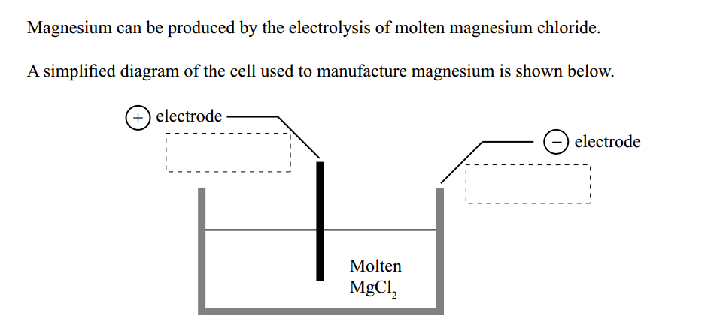

Mg²⁺ must be reduced. Cl⁻ must be oxidised.
E°cell = E°(R) - E°(O), = -2.36 – 1.40 = -3.76V
Reduction: Mg⁺² + 2e → Mg (reduction as ON of Mg is decreasing from +2 in Mg⁺² to 0 in Mg, decrease in ON = reduction)
Oxidation: 2Cl- → Cl₂ + 2e (oxidation as ON of Cl is increasing from to -1 in Cl- to 0 in Cl₂, increase in ON = oxidation)
Overall equation: Mg⁺² + 2Cl- → Mg + Cl₂
Observations: No colour change in the solution as Mg²⁺ is colourless and so is Cl-. At the anode a pale green gas of Cl₂ would appear (probably wouldn’t bubble) and the cathode would be coated in a grey/silver solid/liquid of Mg.
The E°cell is negative, therefore the reaction is non-spontaneous. For this reaction to occur, an input of electrical energy is required from the power supply.
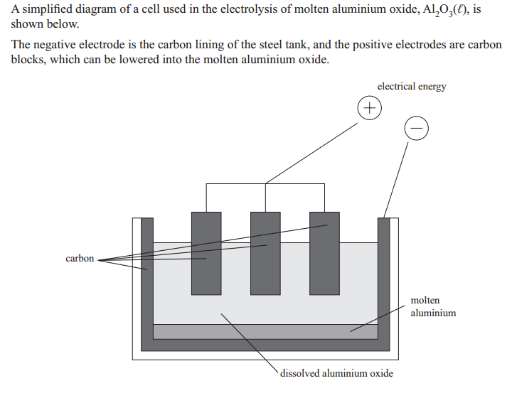

Cell 3

Al³⁺ must be reduced. O²⁻ must be oxidised.
E°cell = E°(R) - E°(O), = -2.36 – 1.40 = -3.76V
Reduction: Mg⁺² + 2e → Mg (reduction as ON of Mg is decreasing from +2 in Mg⁺² to 0 in Mg, decrease in ON = reduction)
Oxidation: 2Cl- → Cl₂ + 2e (oxidation as ON of Cl is increasing from to -1 in Cl- to 0 in Cl₂, increase in ON = oxidation)
Overall equation: Mg⁺² + 2Cl- → Mg + Cl₂
Observations: No colour change in the solution as Mg²⁺ is colourless and so is Cl-. At the anode a pale green gas of Cl₂ would appear (probably wouldn’t bubble) and the cathode would be coated in a grey/silver solid/liquid of Mg.
The E°cell is negative, therefore the reaction is non-spontaneous. For this reaction to occur, an input of electrical energy is required from the power supply.

Cell 4
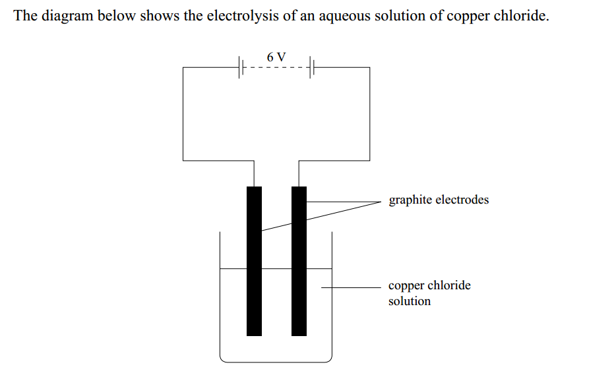

As the electrodes are inert, Cu²⁺ OR H₂O must be reduced. Cl⁻ OR H₂O must be oxidised.
As E°cell (Cu/Cu²⁺) = +0.34 V and (H₂O/H₂) = 0.00V, then copper ions will be reduced as the E°cell is more positive.
As E°cell (Cl-/Cl₂) = +1.40 V and (H₂O/O₂) = +0.82 V, then water will be oxidised as the E°cell is more negative.
E°cell = E°(R) - E°(O), = + 0.34 V – +0.82 V = -0.50 V
Reduction: Cu⁺² + 2e → Cu (reduction as ON of Cu is decreasing from +2 in Cu⁺² to 0 in Cu, decrease in ON = reduction)
Oxidation: 2H₂O → O₂ + 4H⁺ + 4e (oxidation as ON of O is increasing from to -2 in H₂O to 0 in O₂, increase in ON = oxidation)
Overall equation: 2Cu⁺² + 2H₂O → 2Cu + O₂ + 4H⁺
Observations: The blue solution lightens as Cu2+ is reduced to Cu (decrease in concentration of Cu²⁺). This is reduction therefore occurs at the cathode. In addition the anode increase in mass as a red brown solid of Cu forms on it. At the anode bubbles of a colourless gas appear (O₂) as H₂O (colourless liquid) is oxidised to O₂.
The E°cell is negative, therefore the reaction is non-spontaneous. For this reaction to occur, an input of electrical energy is required from the power supply.

Cell 5
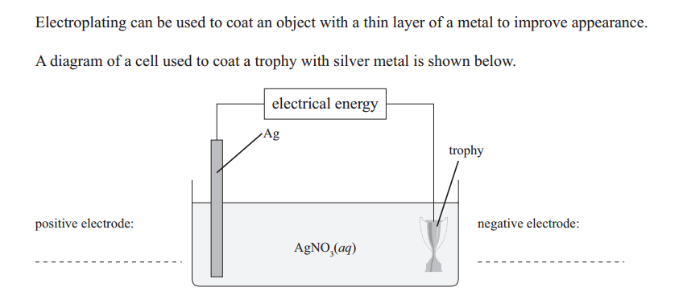

Cell 6

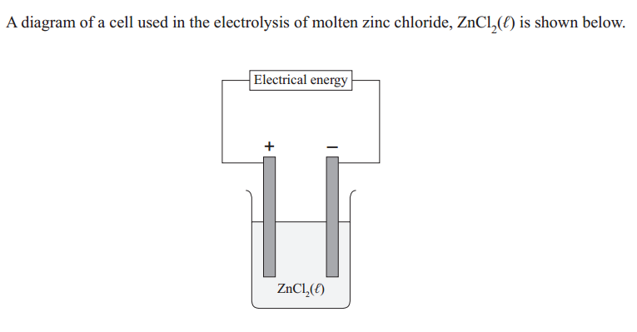

Cell 7 What is the same and different about these 2 cells? How does that affect the products?
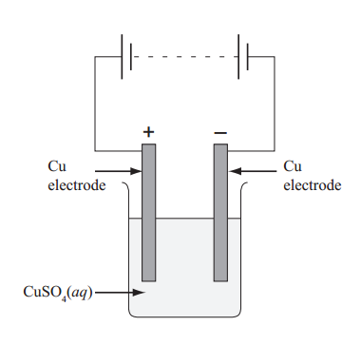
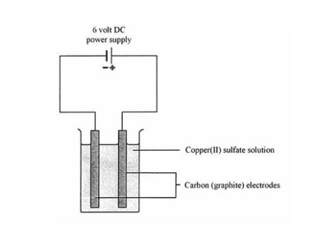

Same: Both will reduce Cu²⁺ ions to copper.
Different: In the cell with copper electrodes, the Cu metal can be oxidised to form Cu2+ and therefore the reaction can continue to make Cu (eg in electroplating)
RIGHT CELL: As the electrodes are inert, Cu²⁺ OR H₂O OR SO₄²⁻ must be reduced. ONLY H₂O must be oxidised (as SO₄²⁻ cannot be oxidised further)
As E°cell (Cu/Cu²⁺) = +0.34 V, (SO₄²⁻/SO2) = +0.16 V and (H₂O/H₂) = 0.00V, then copper ions will be reduced as the E°cell is the most positive.
E°cell = E°(R) - E°(O), = + 0.34 V – +0.82 V = -0.50 V
Reduction: Cu⁺² + 2e → Cu (reduction as ON of Cu is decreasing from +2 in Cu⁺² to 0 in Cu, decrease in ON = reduction)
Oxidation: 2H₂O → O₂ + 4H⁺ + 4e (oxidation as ON of O is increasing from to -2 in H₂O to 0 in O₂, increase in ON = oxidation)
Overall equation: 2Cu⁺² + 2H₂O → 2Cu + O₂ + 4H⁺
Observations: The blue solution lightens as Cu²⁺ is reduced to Cu (decrease in concentration of Cu²⁺). This is reduction therefore occurs at the cathode. In addition the cathode increases in mass as a red brown solid of Cu forms on it. At the anode bubbles of a colourless gas appear (O₂) as H₂O (colourless liquid) is oxidised to O₂.
The E°cell is negative, therefore the reaction is non-spontaneous. For this reaction to occur, an input of electrical energy is required from the power supply.

LEFT CELL:
As the electrodes are reactive, Cu²⁺ OR H₂O OR SO₄²⁻ must be reduced. H₂O OR Cu can be oxidised (as SO₄²⁻ cannot be oxidised further)
As E°cell (Cu/Cu²⁺) = +0.34 V, (SO₄²⁻/SO2) = +0.16 V and (H₂O/H₂) = 0.00V, then copper ions will be reduced as the E°cell is the most positive.
As E°cell (Cu/Cu²⁺) = +0.34 V, (H₂O/O₂) = +0.82V, then copper will be oxidised as the E°cell is the most negative.
E°cell = E°(R) - E°(O), = + 0.34 V – 0.34 V = 0.00 V
Reduction: Cu⁺² + 2e → Cu (reduction as ON of Cu is decreasing from +2 in Cu⁺² to 0 in Cu, decrease in ON = reduction)
Oxidation: Cu→ Cu⁺² + 2e (oxidation as ON of Cu is increasing from to 0 in Cu to +2 in Cu²⁺, increase in ON = oxidation)
Overall equation: Cu⁺² + Cu → Cu + Cu⁺²
Observations: The blue solution DOES NOT CHANGE COLOUR as Cu²⁺ is reduced to Cu and Cu is oxidised to Cu²⁺, thus the concentration of blue Cu²⁺ ions remains constant and the colour stays the same blue. This is reduction therefore occurs at the cathode. In addition the cathode increases in mass as a red brown solid of Cu forms on it. The anode decreases in mass as the red brown solid is oxidised to Cu²⁺.
The E°cell is zero, therefore the reaction is non-spontaneous. For this reaction to occur, an input of electrical energy is required from the power supply.

Cell 8 Electrolysis of aqueous NaCl

