Analysing ELECTROCHEMICAL cells - answers
For each cell described below:
  - Describe the observations and relate your observations to the species involved
  - Describe what is being oxidised and what is being reduced in each cell. Justify the oxidation and reduction half reactions in terms of e transfer and/or oxidation number
  - Write half equations and then a balanced net ionic equation
  - Calculate cell potentials using your data sheet, state whether the reaction is spontaneous or not and relate this to energy input/output

Cell 1
Cell 1
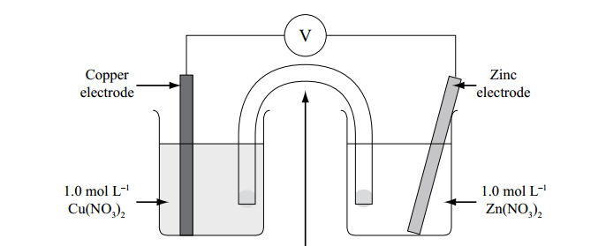

Assume the Cu half cell is oxidation and the Zinc is reduction
E°cell = E°(R) - E°(O), = 0.34 – -0.76 = 1.10V – positive Ecell means this is the correct direction.
Reduction: Zn²⁺ + 2e → Zn (reduction as ON of Zn is decreasing from +2 in Zn⁺² to 0 in Zn, decrease in ON = reduction)
Oxidation: Cu →Cu²⁺ + e (oxidation as ON of Cu is increasing from to 0 in Cu to +2 in Cu⁺², increase in ON = oxidation)
Overall: Zn²⁺ + Cu → Zn + Cu²⁺
Observations LHC: Blue Cu²⁺ is being produced by oxidation so the blue colour would darken. The anode (copper electrode) would decrease in mass as Cu is oxidised.
RHC: Colourless Zn²⁺ is reduced to Zn at the cathode. The colour of the solution will not change, but the electrode would increase in mass as a grey solid (Zn) is deposited.
The E°cell is positive, therefore the reaction is spontaneous in the direction calculated (i.e. reduction in the Zn half cell and oxidation in the Cu half cell). As this spontaneous reaction occurs, the chemical potential energy is converted into electrical energy as seen in the positive voltage (can be used e.g. in a battery)

Cell 2 – Metal X is Al and the solution is Al(NO₃)₃
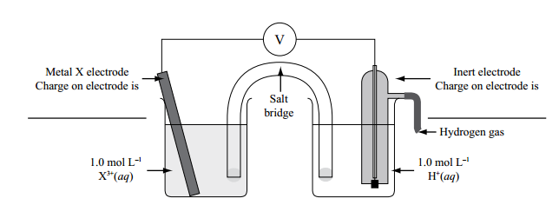

Assume the Al half cell is oxidation and the H is reduction
E°cell = E°(R) - E°(O), = 0.00 – -1.66 = 1.66V – positive Ecell means this is the correct direction.
Reduction: 2H⁺ →H₂ + 2e (reduction as ON of H is decreasing from +1 in H⁺ to 0 in H₂, decrease in ON = reduction)
Oxidation: Al + 3e → Al³⁺ (oxidation as ON of Al is increasing from to 0 in Al to +3 in Al⁺³, increase in ON = oxidation)
Overall: 2Al + 6H⁺ → 2Al³⁺+ 3H₂
Observations LHC: Colourless Al³⁺ is produced from Al at the anode. The colour of the solution will not change, but the electrode would decrease in mass as a grey solid (Al) oxidised.
RHC: There are no observable colour changes as H⁺ is colourless in solution (although the acidity would decrease). There may be an increased rate of bubbling as the production of colourless H₂ gas by reduction increases.
The E°cell is positive, therefore the reaction is spontaneous in the direction calculated (i.e. reduction in the H half cell and oxidation in the Al half cell). As this spontaneous reaction occurs, the chemical potential energy is converted into electrical energy as seen in the positive voltage (can be used e.g. in a battery)

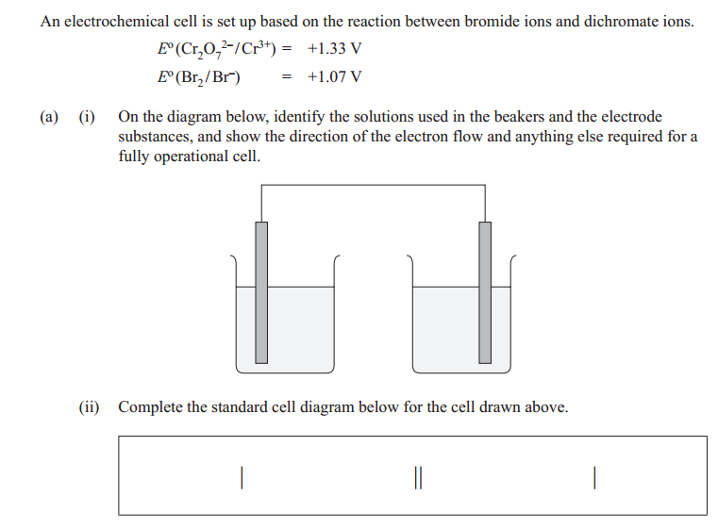
Cell 3

Assume the Br half cell is oxidation and the Cr is reduction
E°cell = E°(R) - E°(O), = 1.33 – 1.07 = 0.26V – positive Ecell means this is the correct direction.
Pt/Br⁻,Br₂//Cr₂O₇²⁻,Cr³⁺/Pt
Reduction: Cr₂O₇²⁻ + 14H⁺ + 6e → 2Cr³⁺ +7H₂O (reduction as ON of Cr is decreasing from +6 in Cr₂O₇²⁻ to +3 in Cr³⁺, decrease in ON = reduction)
Oxidation: 2Br⁻→ Br₂ + 2e (oxidation as ON of Br is increasing from to -1 in Br- to 0 in Br₂, increase in ON = oxidation)
Overall: Cr₂O₇² ⁻ + 14H⁺ + 6Br- → 2Cr³⁺ +7H₂O + 3Br₂
Observations LHC: Orange Br2 is produced from the oxidation of colourless Br-. The colour would turn a darker orange.
RHC: Cr₂O₇²⁻ is orange in solution and Cr³⁺is green. The solution is a mixture of these. As the dichromate is reduced to chromium (III) ions, the solution would turn more green
The E°cell is positive, therefore the reaction is spontaneous in the direction calculated (i.e. reduction in the Cr half cell and oxidation in the Br half cell). As this spontaneous reaction occurs, the chemical potential energy is converted into electrical energy as seen in the positive voltage (can be used e.g. in a battery)

Cell 4
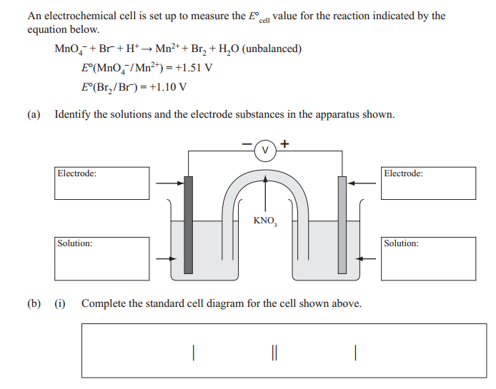

Assume the Br half cell is oxidation and the Mn is reduction
E°cell = E°(R) - E°(O), = 1.51 – 1.10 = 0.41V – positive Ecell means this is the correct direction.
Pt/Br⁻,Br₂//MnO₄⁻,Mn²⁺/Pt
Reduction: MnO₄⁻ + 8H⁺+ 5e + → 4H₂O + Mn²⁺ (reduction as ON of Mn is decreasing from +7 in MnO₄⁻ to +2 in Mn²⁺, decrease in ON = reduction)
Oxidation: 2Br⁻→ Br₂ + 2e (oxidation as ON of Br is increasing from to -1 in Br- to 0 in Br₂, increase in ON = oxidation)
Overall: 2MnO₄⁻ + 16H⁺ + 10Br⁻→ 5Br₂ + 8H₂O + 2Mn²⁺
Observations LHC: Orange Br₂ is produced from the oxidation of colourless Br⁻. The colour would turn a darker orange.
RHC: MnO₄⁻ is purple in solution and Mn²⁺is colourless. The solution is purple. As the permanganate is reduced to manganese (II) ions, the purple solution would lighten
The E°cell is positive, therefore the reaction is spontaneous in the direction calculated (i.e. reduction in the Mn half-cell and oxidation in the Br half cell). As this spontaneous reaction occurs, the chemical potential energy is converted into electrical energy as seen in the positive voltage (can be used e.g. in a battery)

Cell 5
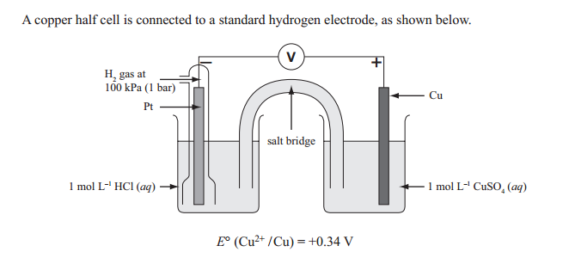

Assume the Cu half-cell is oxidation and the H is reduction
E°cell = E°(R) - E°(O), = 0.00 – 0.34 = -0.34V – negative Ecell means this reaction will occur in the opposite direction to this calculation – i.e. Cu is reduction and H is oxidation.
Reduction: Cu²⁺ +2e → Cu (reduction as ON of Cu is decreasing from +2 in Cu⁺² to 0 in Cu to, decrease in ON = reduction)
Oxidation: H₂→ 2H⁺ + 2e (oxidation as ON of H is increasing from 0 in H₂ to +1 in H⁺, increase in ON = oxidation)
Overall: H₂ + Cu²⁺ → Cu + 2H⁺
Observations LHC: There are no observable colour changes as H⁺ is colourless in solution (although the acidity would increase). There may be a decreased rate of bubbling as the oxidation of colourless H₂ gas decreases the concentration of H₂.
RHC: Blue Cu²⁺ is reduced to red/brown solid of Cu at the cathode. The blue colour of the solution will lighten, and the electrode would increase in mass as a red/brown solid (Cu) is formed.
The E°cell is positive in the direction stated, therefore the reaction is spontaneous in the direction calculated (i.e. reduction in the Cu half cell and oxidation in the H half cell). As this spontaneous reaction occurs, the chemical potential energy is converted into electrical energy as seen in the positive voltage (can be used e.g. in a battery)

Cell 6
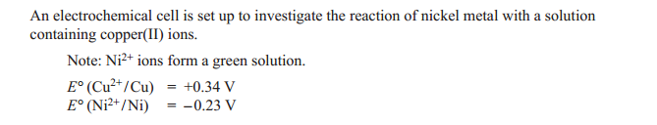

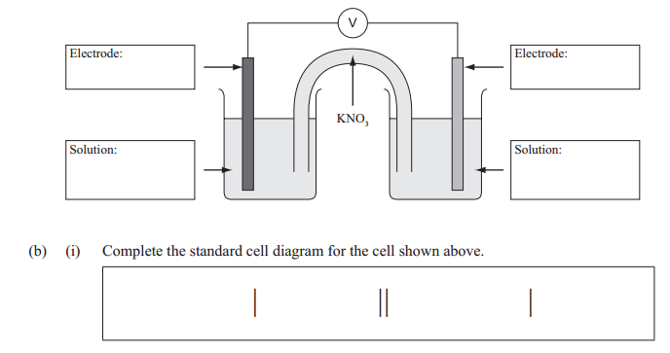

Assume the Cu half-cell is oxidation and the Ni is reduction
E°cell = E°(R) - E°(O), = -0.23 – 0.34 = -0.57V – negative Ecell means this reaction will occur in the opposite direction to this calculation – i.e. Cu is reduction and Ni is oxidation.
Ni/Ni²⁺//Cu²⁺/Cu
Reduction: Cu²⁺ +2e → Cu (reduction as ON of Cu is decreasing from +2 in Cu⁺² to 0 in Cu to, decrease in ON = reduction)
Oxidation: Ni→ Ni⁺² + 2e (oxidation as ON of Ni is increasing from 0 in Ni to +2 in Ni⁺², increase in ON = oxidation)
Overall: Ni + Cu²⁺ → Cu + Ni⁺²
Observations LHC (Ni): The grey electrode of Ni would decrease in mass/erode as Ni is oxidised to Ni²⁺. The solution would begin as a pale green due to Ni²⁺ and this would get darker green as the concentration of Ni²⁺ increases by oxidation of Ni
RHC: Blue Cu²⁺ is reduced to red/brown solid of Cu at the cathode. The blue colour of the solution will lighten, and the electrode would increase in mass as a red/brown solid (Cu) is formed.
The E°cell is positive in the direction stated, therefore the reaction is spontaneous in the direction calculated (i.e. reduction in the Cu half cell and oxidation in the Ni half cell). As this spontaneous reaction occurs, the chemical potential energy is converted into electrical energy as seen in the positive voltage (can be used e.g. in a battery)

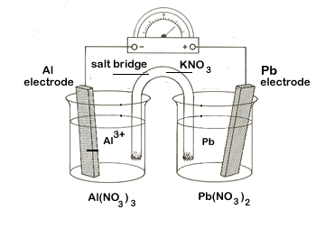
Cell 7

Assume the Al half cell is oxidation and the Pb is reduction
E°cell = E°(R) - E°(O), =-0.13 – -1.66 = 1.53V – positive Ecell means this is the correct direction.
Reduction: Pb²⁺+ 2e → Pb (reduction as ON of Pb is decreasing from +2 in Pb²⁺ to 0 in Pb, decrease in ON = reduction)
Oxidation: Al + 3e → Al³⁺ (oxidation as ON of Al is increasing from to 0 in Al to +3 in Al⁺³, increase in ON = oxidation)
Overall: 2Al + 3Pb → 2Al³⁺+ 3Pb²⁺
Observations LHC: Colourless Al³⁺ is produced from Al at the anode. The colour of the solution will not change, but the electrode would decrease in mass as a grey solid (Al) oxidised.
RHC: The electrode would increase in mass as the grey solid Pb is produced by reduction of the colourless solution Pb²⁺. The colour of the solution would not change.
The E°cell is positive, therefore the reaction is spontaneous in the direction calculated (i.e. reduction in the Pb half cell and oxidation in the Al half cell). As this spontaneous reaction occurs, the chemical potential energy is converted into electrical energy as seen in the positive voltage (can be used e.g. in a battery)
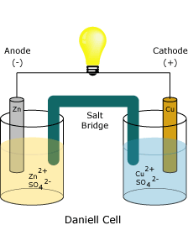

Cell 8

Assume the Cu half-cell is oxidation and the Zn is reduction
E°cell = E°(R) - E°(O), = -0.76 – 0.34 = -1.10V – negative Ecell means this reaction will occur in the opposite direction to this calculation – i.e. Cu is reduction and Zn is oxidation.
Zn/Zn²⁺//Cu²⁺/Cu
Reduction: Cu²⁺ +2e → Cu (reduction as ON of Cu is decreasing from +2 in Cu⁺² to 0 in Cu to, decrease in ON = reduction)
Oxidation: Zn→ Zn⁺² + 2e (oxidation as ON of Zn is increasing from 0 in Zn to +2 in Zn⁺², increase in ON = oxidation)
Overall: Zn + Cu²⁺ → Cu + Zn⁺²
Observations LHC (Zn): The grey electrode of Zn would decrease in mass/erode as Zn is oxidised to Zn²⁺. The solution would be colourless due to Zn²⁺ and this not change
RHC: Blue Cu²⁺ is reduced to red/brown solid of Cu at the cathode. The blue colour of the solution will lighten, and the electrode would increase in mass as a red/brown solid (Cu) is formed.
The E°cell is positive in the direction stated, therefore the reaction is spontaneous in the direction calculated (i.e. reduction in the Cu half cell and oxidation in the Zn half cell). As this spontaneous reaction occurs, the chemical potential energy is converted into electrical energy as seen in the positive voltage (can be used e.g. in a battery)

